PREREQUISITES

|  |  |
| --- | --- |
| Date | 15 November 2022 |
| Team ID | PNT2022TMID30400 |
| Project Name | Project - IoT Based Smart Crop Protection System for Agriculture |
| Team Members | K.SUBASHREE,P.SOBIYA,M.THILOTHAMA, M. SUMITHRA |

IBM-CLOUD ACCOUNT CREATION:

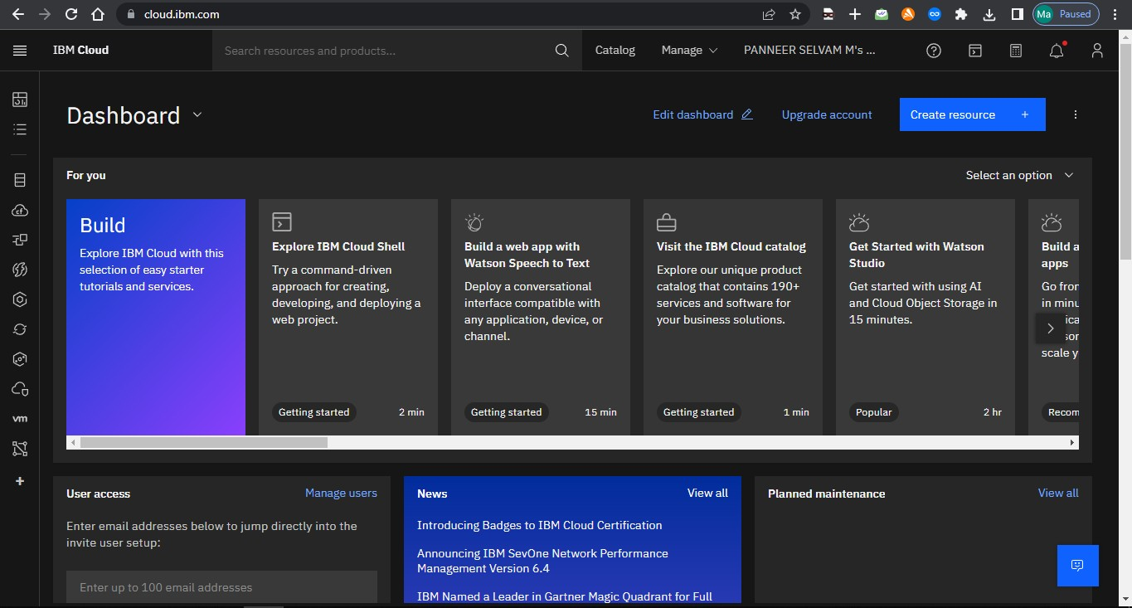

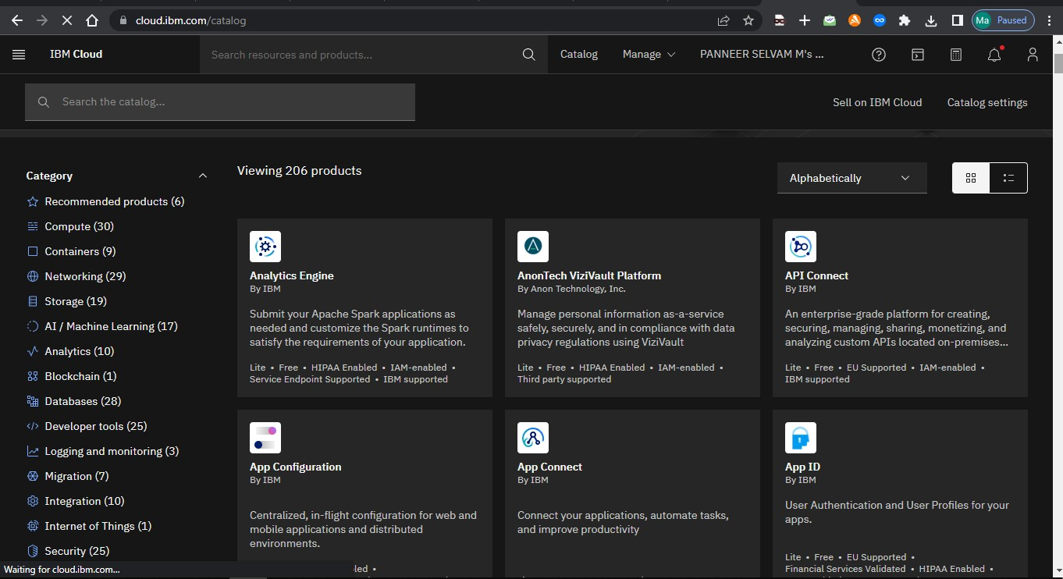



,

I B Clo u d



Catalog



|  |
| --- |
|  |
|  |
|  |
|  |